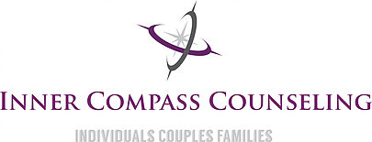
group therapy:
for registration information contact:
letstalk @innercompasscounseling.com ◊ (720) 443-2276

experiencing Infertility
let’s talk about the pain behind your smile
Wednesday Evenings
January 11- February 15
5:00 p.m. - 7:00 p.m.
Inner Compass Counseling
8791 Wolff Ct. Westminster CO, 80031
Are you one of the 10% that are experiencing infertility? We are here to help.
Join us for a 6-week group therapy experience focused on navigating the struggle with infertility. Topics to be covered include: self-worth & body image, accepting your feelings, managing the impact on your relationship, sexual intimacy, societal pressures and more.

